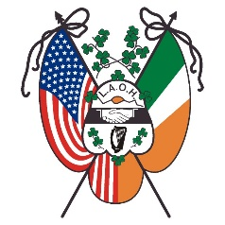
Ladies Ancient Order of Hibernians, Inc.
New York State Board

March 31, 2024

To: LAOH NYS Board Officers-Appointees-Past Presidents, and County-Division Presidents

Call to the May 4, 2024, State Board Meeting

Dear Sisters,

Our Spring NY State LAOH Board ‘General’ Business meeting will be held Saturday, May 4, 2024, at 10:00 A.M. sharp (new time), (9:45 A.M. sign in) at Gavins Irish Country Inn, 118 Golden Hill Road, Cornwallville, NY 12418. (518) 634-2582.

See attached letter from Patricia Moynihan, LAOH NYS Catholic Action Officer, for Reservations and Mass information.

Included with this Call to the State Board Meeting are the following attachments:
- Guidelines for State Board Meeting
- State Board Attendance Sheet
- Reservation and Mass Information Letter

If you have any questions or need any assistance, please do not hesitate to contact me via email at nyslaohsecretary1@gmail.com or by phone at 718.219.4378.

Yours in our motto,
JoAnn Gundersen
JoAnn Gundersen
NYS LAOH Secretary

